**BACKUP RDS**

**Creating EC2 Instance**

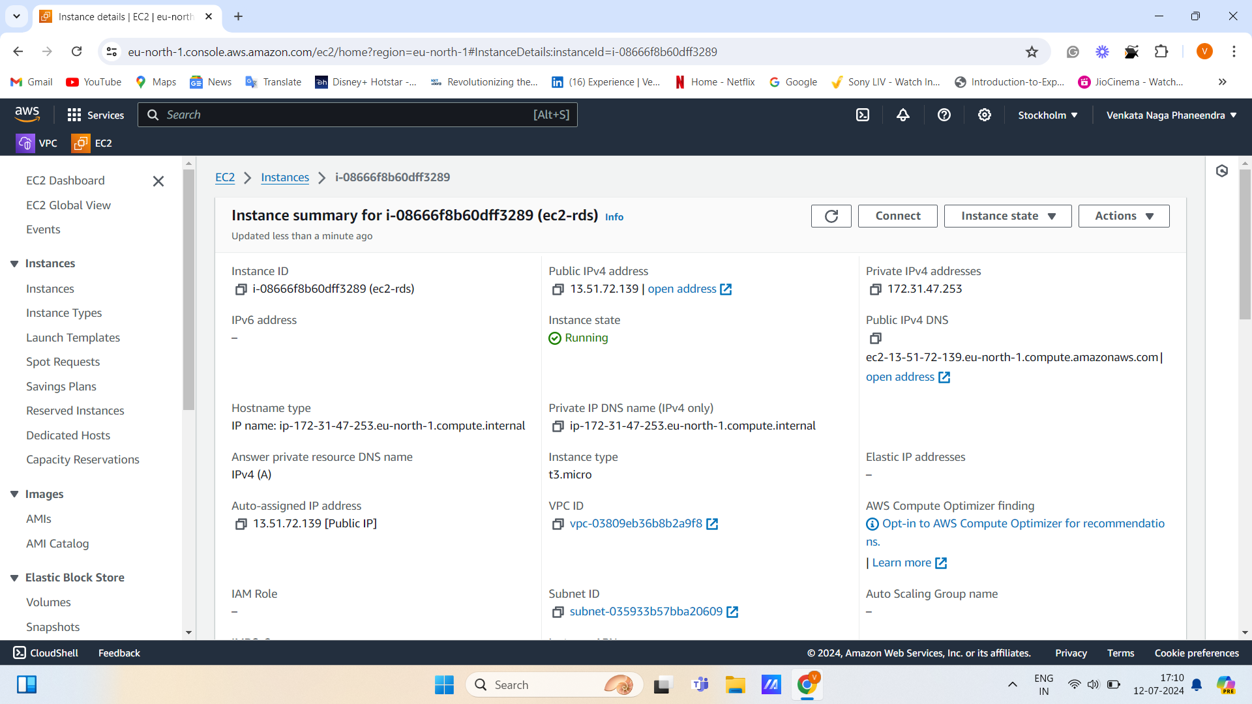

**RDS**

**Create Database**

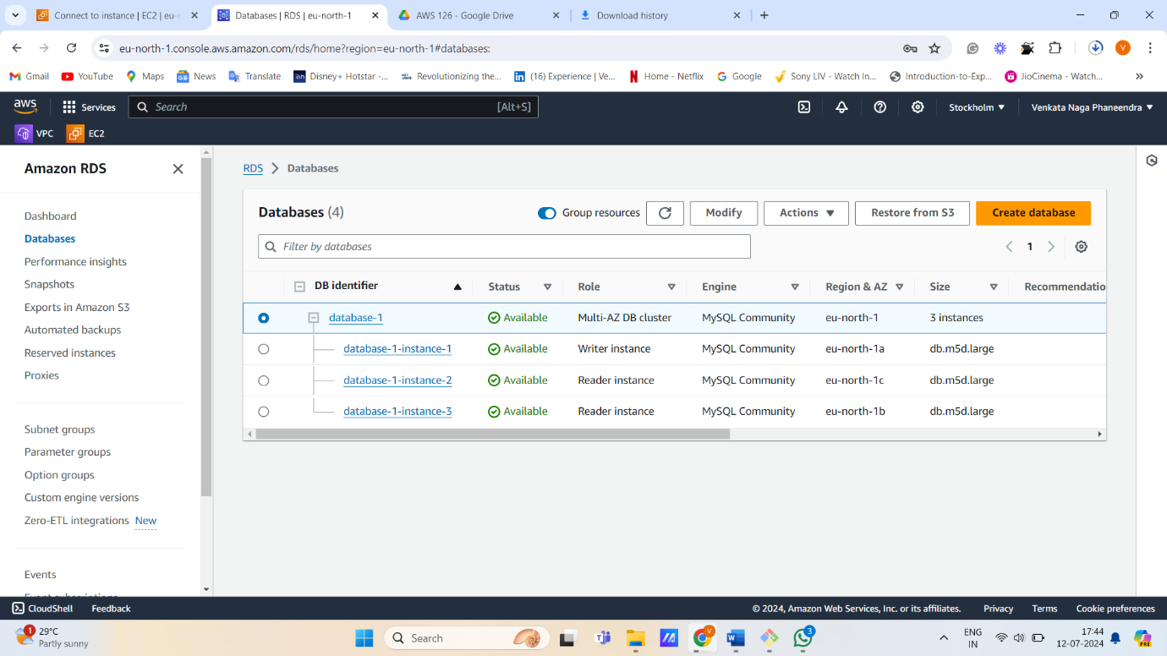

**Connect to instance**

* **Update server**

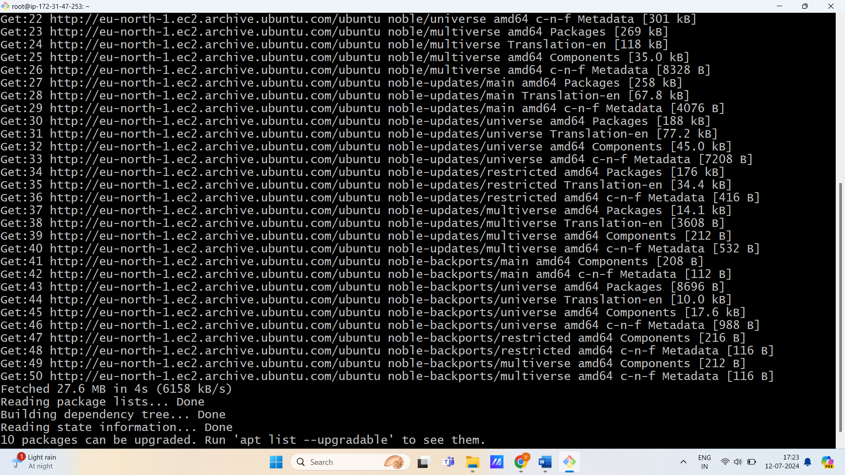

* **Install MySQL-server**

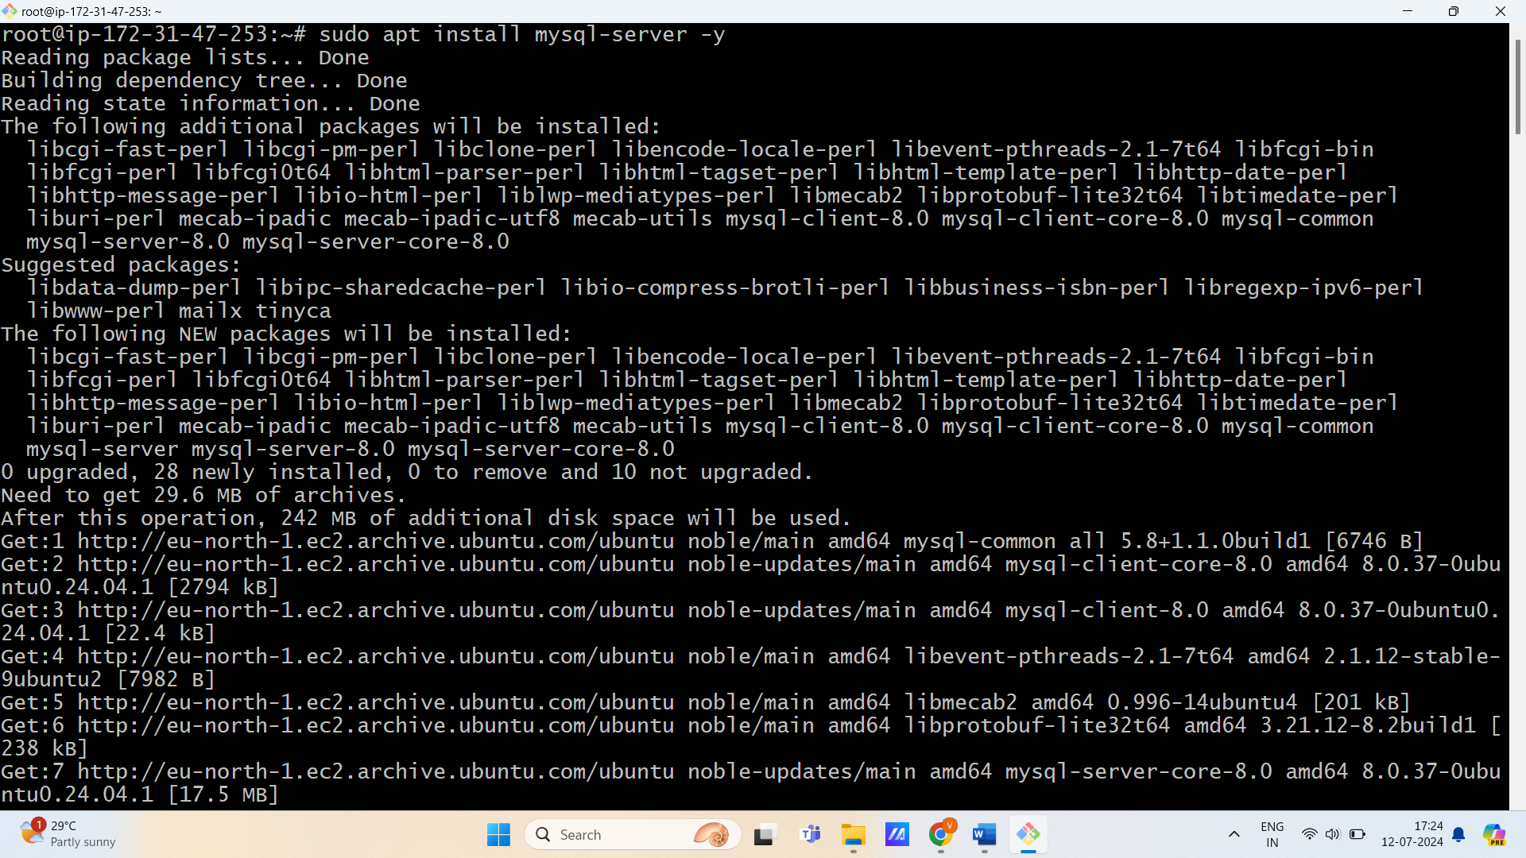

* **Run Mysql server**

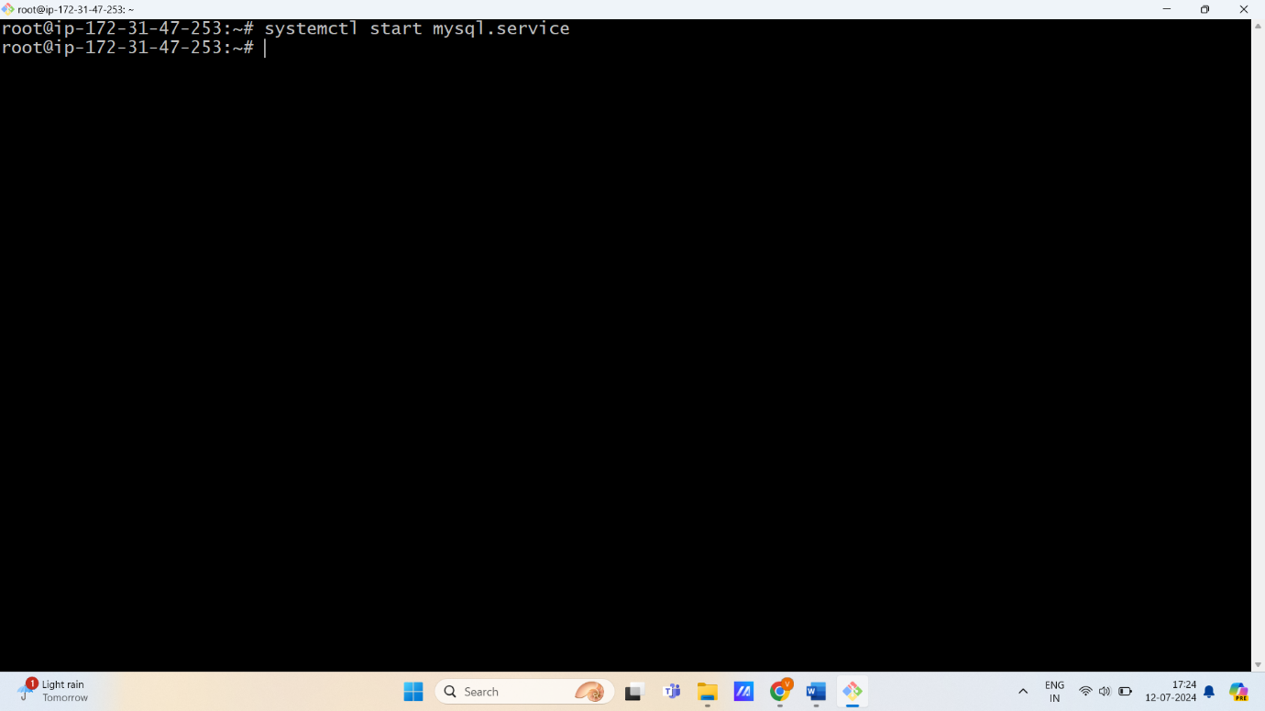

* **Check status of Mysql server**

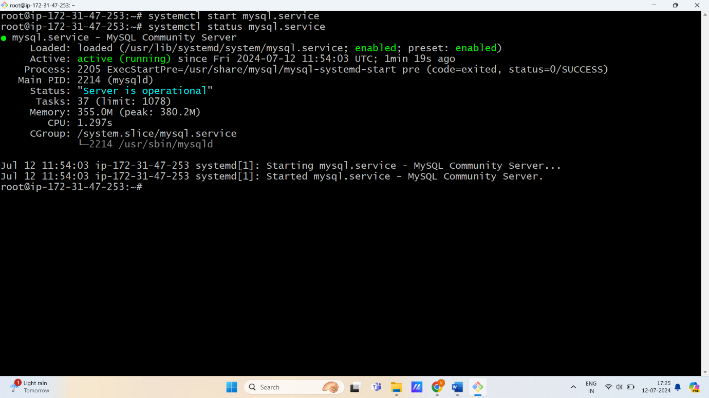

**Set up ec2 instance connection to database**

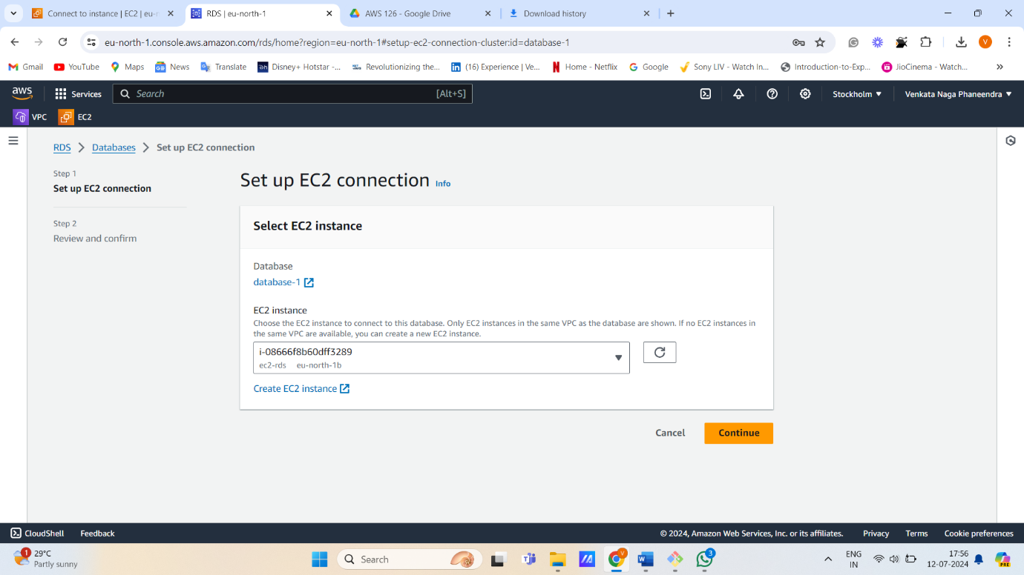

**Connect to Mysql in the server**

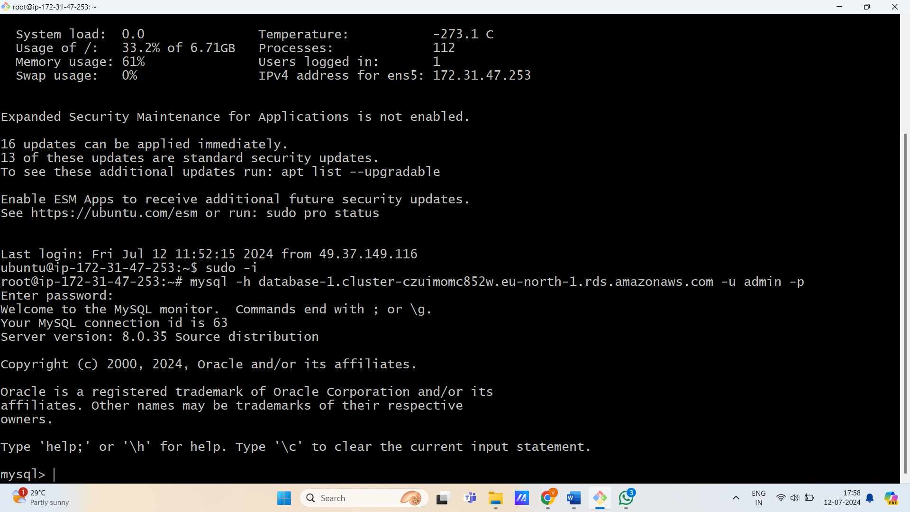

**Run the following commands:**

* **Create database rds && show databases**

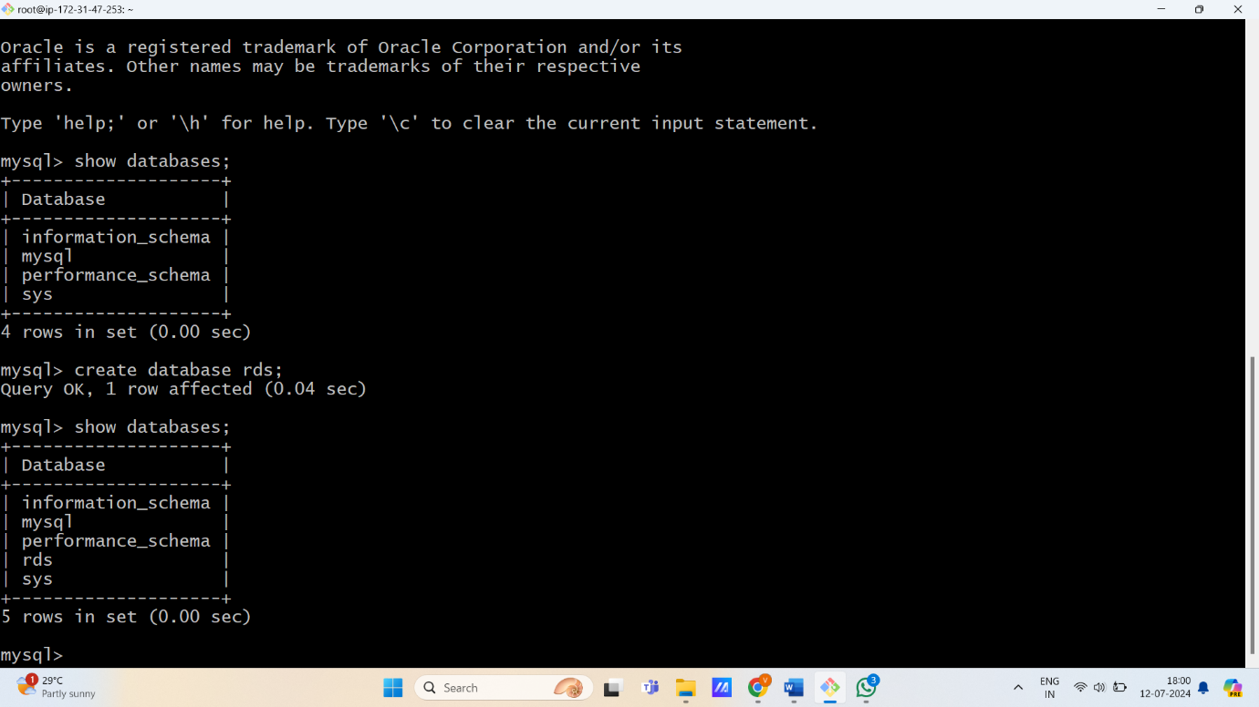

* **Use rds && create table && insert values**

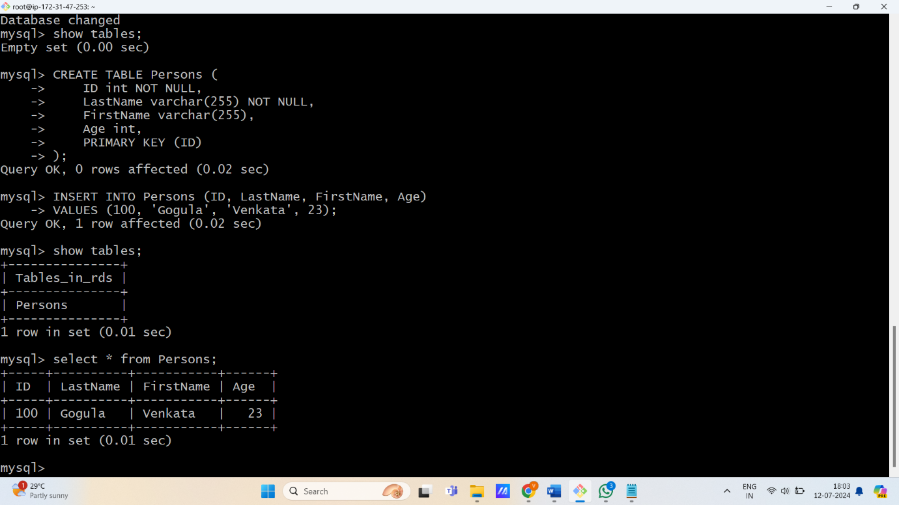

**Create Snapshot**

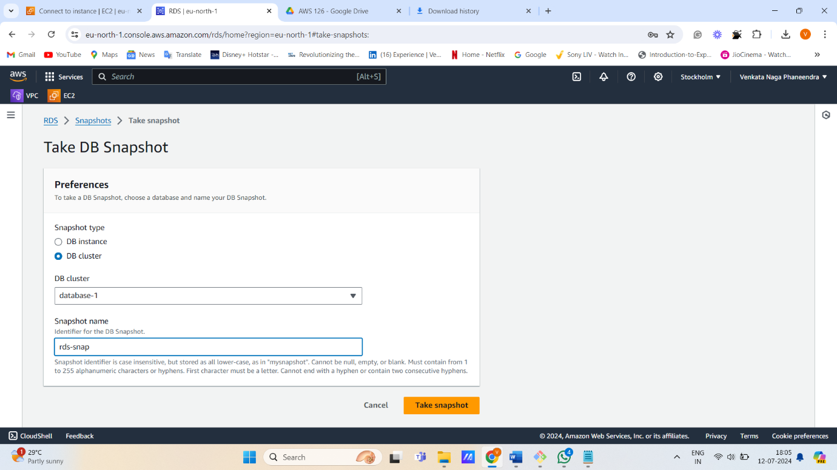

**Delete database**

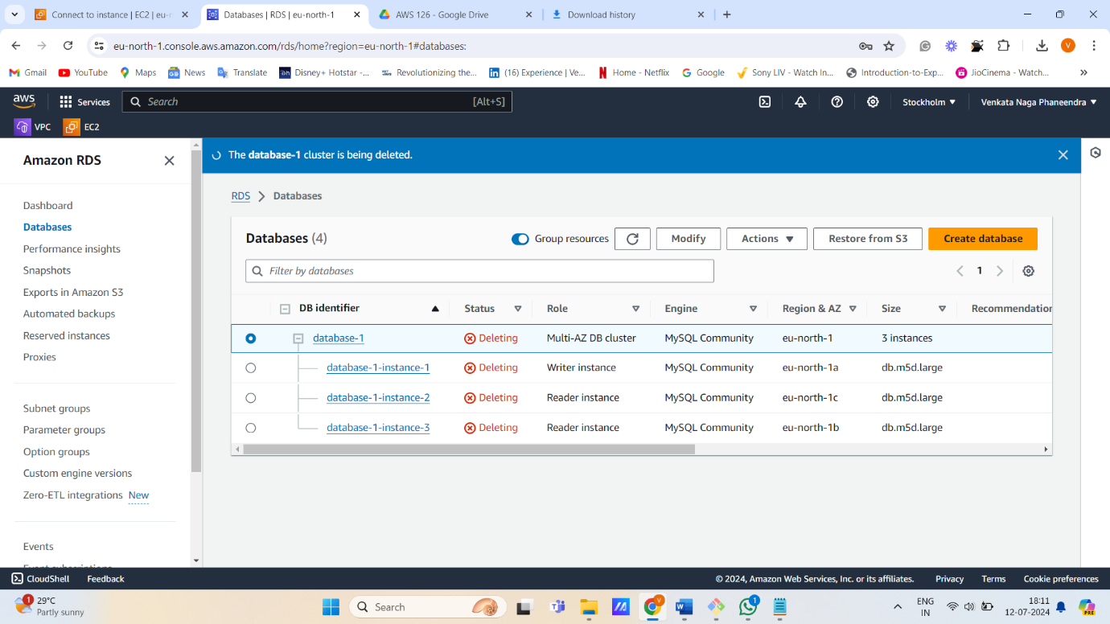

**Restore snapshot**

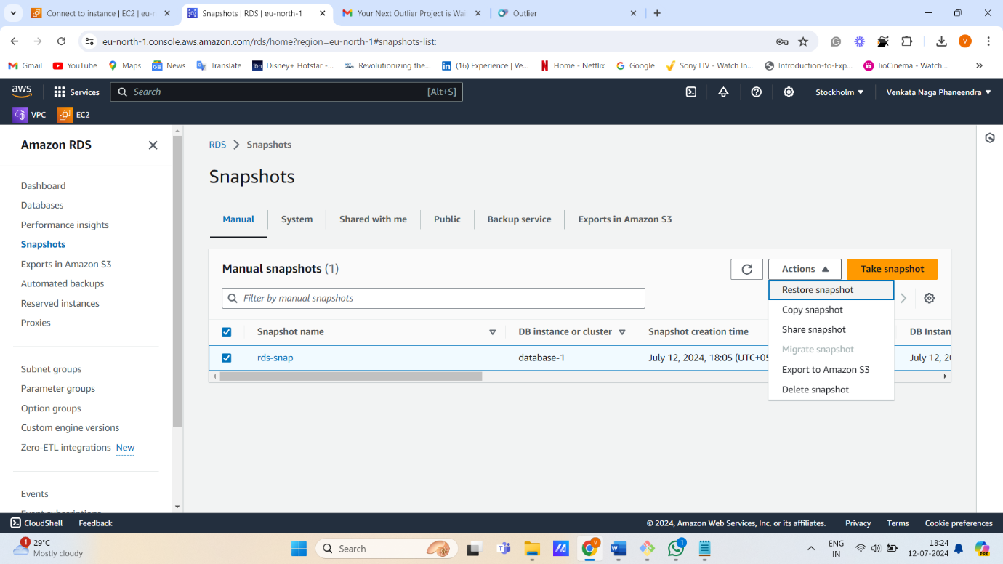

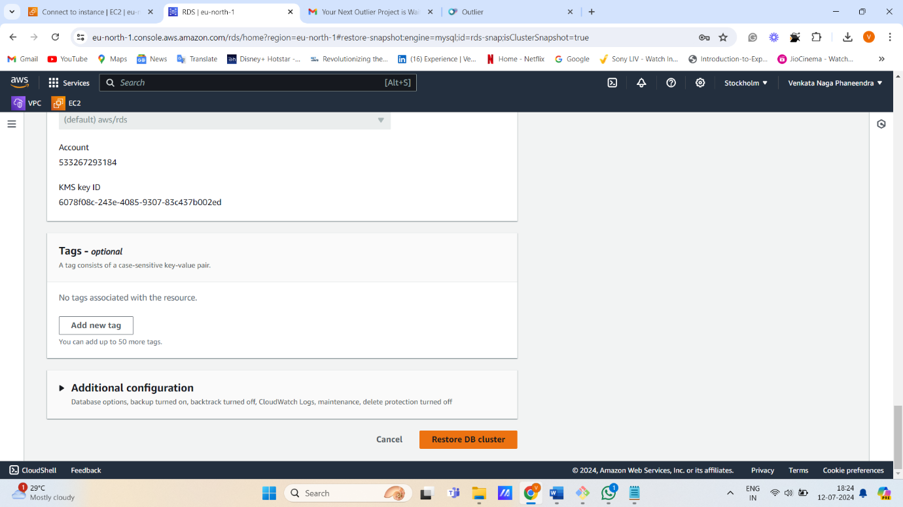

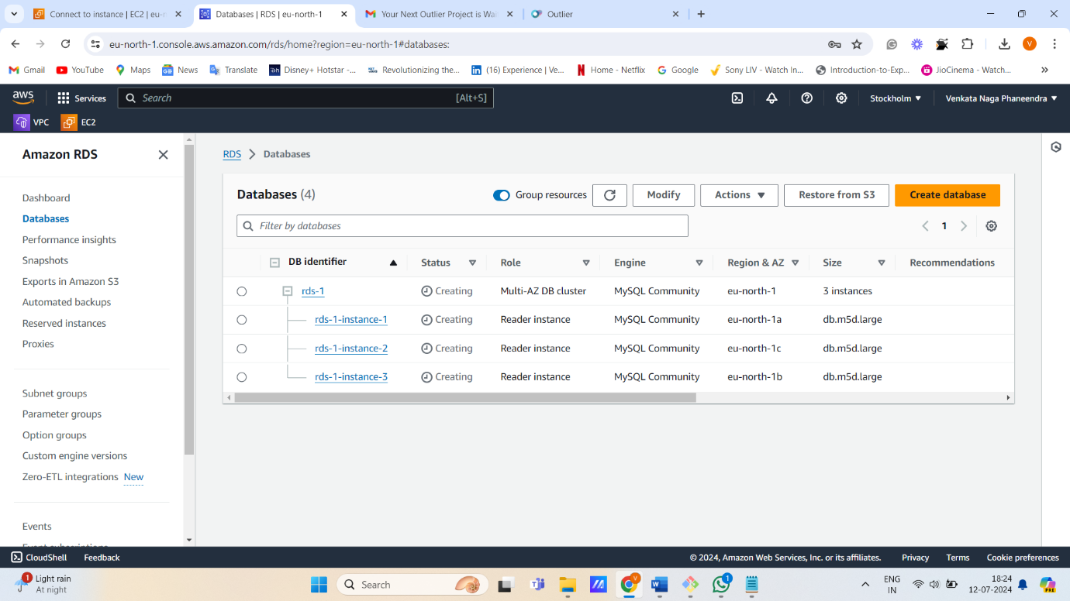

**Again set up ec2 instance**

**Connect to server**

* **Show databases;**
* **Use rds;**
* **Select * from Persons;**

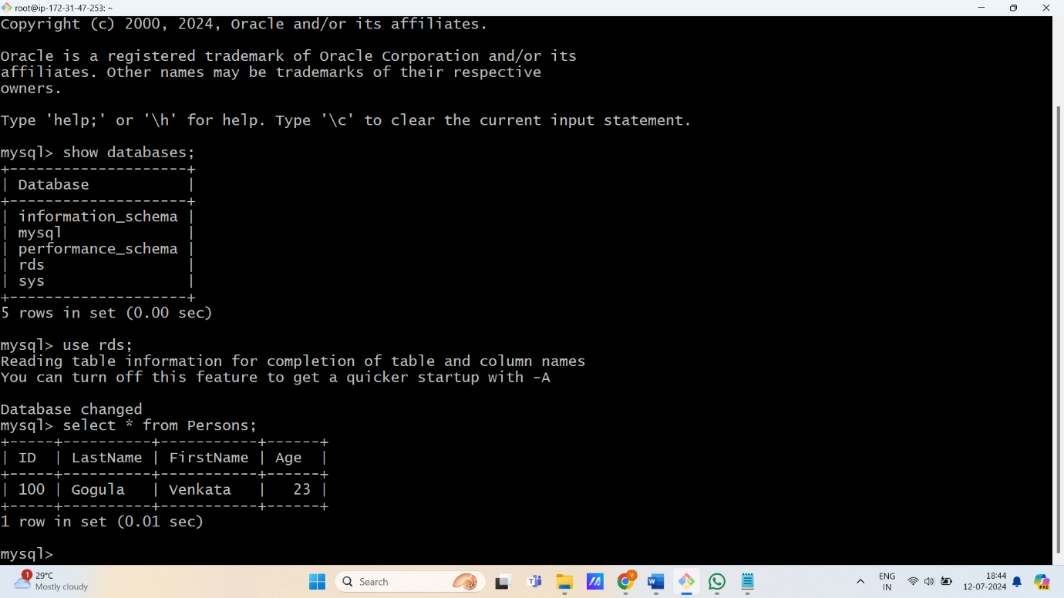

**Successfully Backed up.**